Geometry: Unit 3, Lesson 3
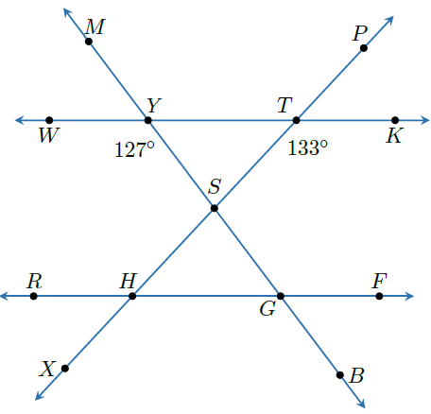
- Lines $XP$, $MB$, $FR$, and $WK$ are shown. $\overset{⃡}{WK}∥\overset{⃡}{FR}$ with $\overset{⃡}{MB}$ and $\overset{⃡}{XP}$ as traversals. $m∠WYS=127°$ and $m∠KTS=133°$. What is the measure of $m∠MYT$?

$$127°$$

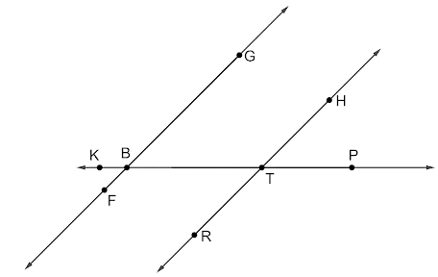
- Lines $FG$, $KP$, and $RH$ are shown. $\overset{⃡}{FG}∥\overset{⃡}{RH}$ and $\overset{⃡}{KP}$ is a traversal. What is the relationship between $∠KBF$ and $∠BTR$

Corresponding Angles

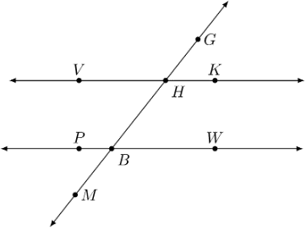
- Lines $VK$, $PW$, and $GM$ are shown. $\overset{⃡}{VK}∥\overset{⃡}{PW}$ and $\overset{⃡}{GM}$ is a traversal. What is an example of a pair of corresponding angles?

$∠GHK$ and $∠HBW$

